Server Setup
Part 1

- Visit Downloads – Oracle VirtualBox
  - Here you can download VirtualBox for whichever platform you have.
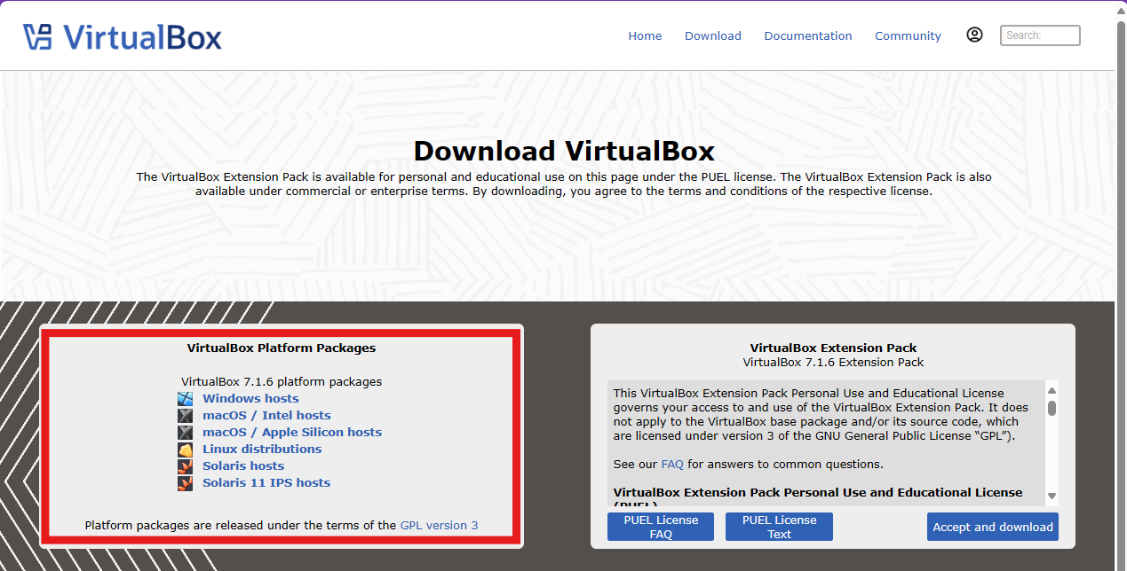 b. Download and complete the setup wizard.

- Visit Download Ubuntu Desktop | Ubuntu
  - Here you can download the UBuntu version we will be using.
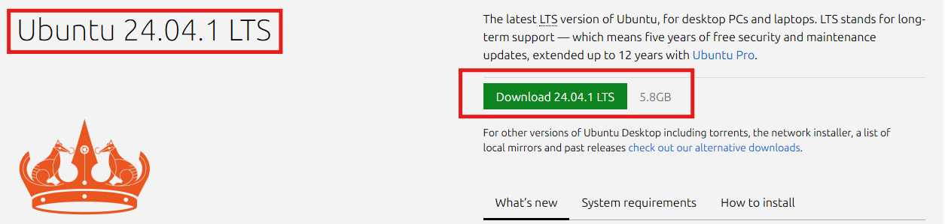
  - The download will start once you click download. You will be directed to another page but you do not have to fill anything out here. This is simply a newsletter sign up. You can leave the download in your Downloads folder for now

- Head back over to the Virtual Machine program.
  - Click “New”
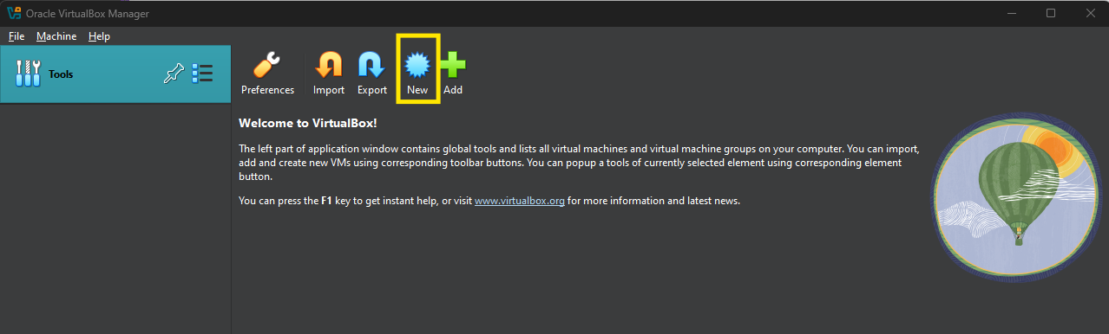
  - After clicking new make sure the information in yellow boxes matches what’s shown in the photo below, then hit “Next”: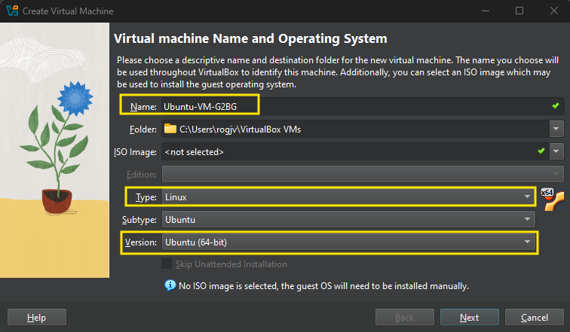

  - Here we’re adjusting how much RAM and how many processors you’re going to use. This will vary depending on the computer/laptop you are using. Hit “Next” when you’re done.
    - Please select at least 4GB of ram (4096MB) or else it will freeze during installation.
    - 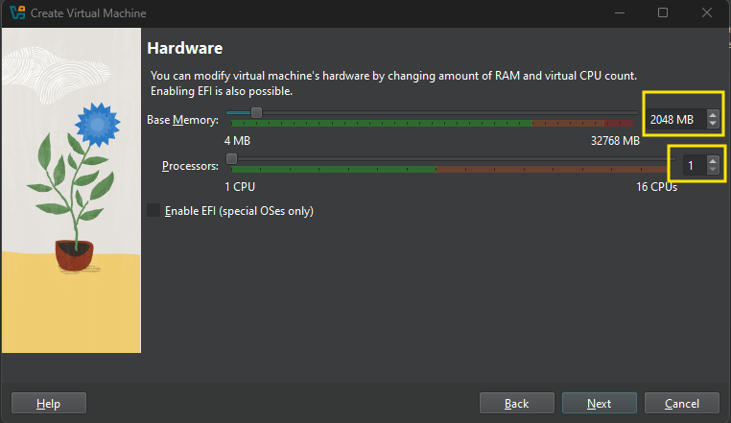

  - I left the default settings for the next window.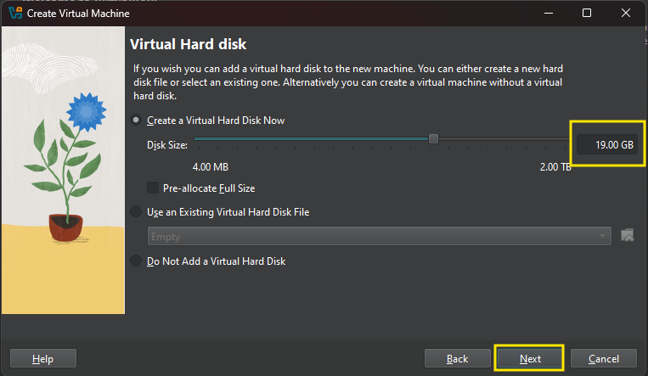

  - On the next window you can just hit “Finish”. It should return you to the homepage and see something like this: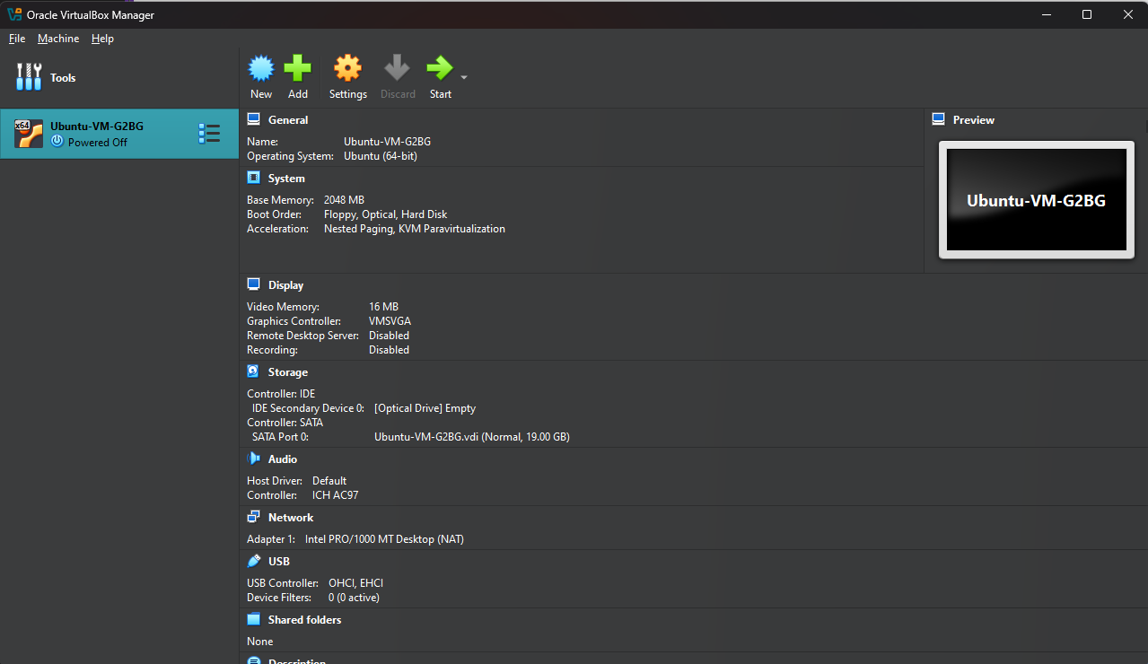NOTE – I had an issue with hitting ”Finish“. I hit ”back” a couple of times until I got to step 1B and changed the file name. After that everything worked fine.

PART 2
- Select your VM and click “Settings”
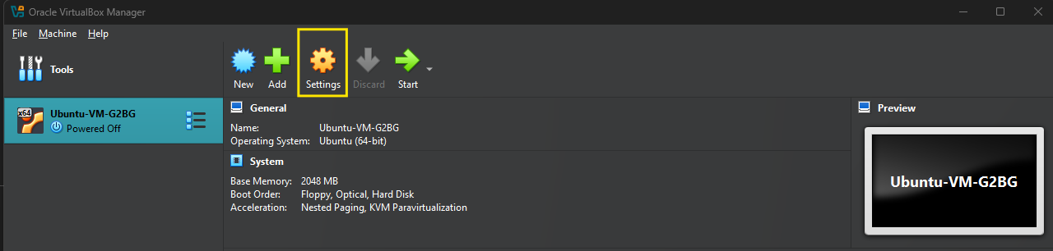
  - Click “Storage” on the left-hand side of the window.
  - Click on the “Empty” disc image under Controller: IDE
  - Under Attributes, click the disk image and select “Choose a Disk File..”
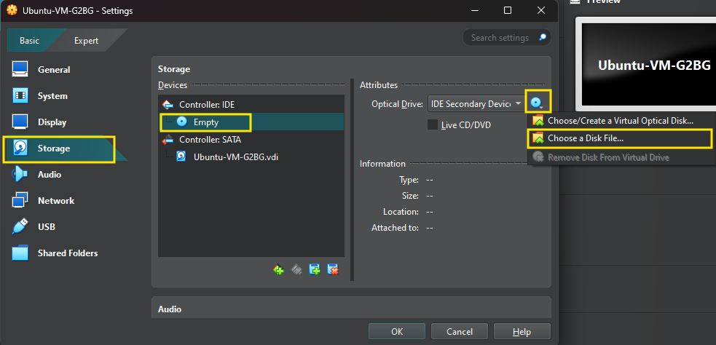
  - Your File Explorer will open. You will need to navigate to where your Ubuntu downloaded from 2B in Part 1. Select it.
  - The “Empty” should now be replaced with ubuntu. Hit “OK” to save the changes.

Part 3
- Once you’re back at your VM click “Start” located at the top with the green arrow.
  - IF you are hit with weird funky error restart your computer and try again
- Click “Install Ubuntu” on the “desktop” that opens up and complete the setup wizard.
  - I chose to update the installer during the installation.
    - This will make you close the installer and start again.
  - When it asks how you would like to install Ubuntu I went with the “Interactive Installation”
  - On the next window select “Default Selection”
  - On the “Install recommended proprietary software” window I selected both but I don’t think it matters much.
  - “How do you want to install Ubuntu” I went with “Erase disk and install Ubuntu”.
  - Create your account
    - Be sure to remember your login and password
  - Continue through and click “Install”
  - Once it does installing you will get a message “Please remove the installation medium”
    - Pause the VM
      - Go to “Machine” on the top bar and click pause
    - Go to “Devices” and select “Optical Drivers” and select “Remove disk from optical drive”
      - If it is grayed out Go to the VirtualBox Manager program.
      - Select Settings > Storage >
      - Under Controller: IDE it should say “Empty”
        - If so return back to the VM and hit enter.
  - Once done it will prompt you to reboot.
    - If it doesn’t, stop the VM and restart it.

- Congrats Ubuntu should now be successfully installed.

Part 4 – OPTIONAL???
- Open up your VM
  - Click Devices > Insert Guest Additions CD Image
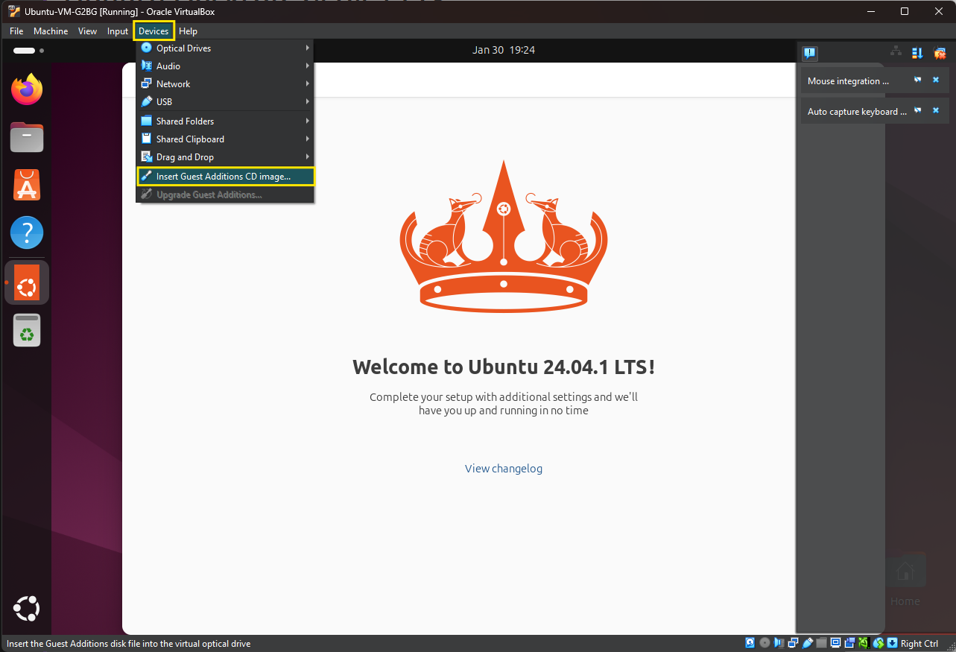
- Hit CTRL + ALT + T
  - This will open a terminal in Ubuntu
  - Please note this part might be frustrating. Please read each instruction carefully and please be patient.
- Type the following
  - “sudo apt update” hit Enter

  - “sudo apt install build-essential dkms” hit Enter
    - If you get something like the image below enter the following command “sudo apt upgrade -y”
      - This ill update all the packages before installing new software.
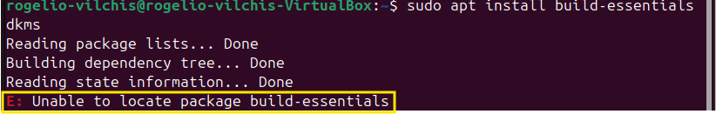
    - If it still doesn’t work ..
    - Type “sudo add-apt-repository universe” Hit enter
    - Then “sudo apt update” Hit Enter
    - then try “sudo apt install build-essential dkms -y” and Hit Enter

  - If you still cant located build-essentials….
    - Type “apt search build-essentials” hit Enter
    - Once again type “sudo apt install build-essential dkms -y” hit Enter

  - If you still have issues try
    - “sudo apt update --fix-missing” hit Enter
    - Retry “sudo apt install build-essential dkms -y” hit Enter
    - Locate “build-essentials”
      - It’s alphabetical order
    - Type “sudo add-apt-repository universe” hit enter
    - Then type “sudo apt update” hit Enter
    - Type “apt search build-essential” hit Enter
    - Type “sudo apt install build-essential -y” hit Enter

  - Type “ls /media/$USER/”
    - This will get your VERSION
  - Type “sudo /media/your_username/VBox_GAs_VERSION/VBoxLinuxAdditions.run”
  - If that doesn’t work type “sudo /media/$USER/VBox_GAs_*/VBoxLinuxAdditions.run” then hit enter.
  - If it worked a bunch of syntax should appear .
    - Restart your VM
Part 5
- Open up your VM
- Open a terminal window
  - CTRL + ALT + T

- We are going to update Ubuntu again
  - Type “sudo apt update” hit Enter
  - Type “sudo apt upgrade” hit Enter

- Now we are going to install Node.js
  - Type “sudo apt install nodejs npm” hit Enter
  - You will be prompted to accept the storage usage
    - Type “Y” then hit Enter.
  - Wait for Node.js to install

- Now we install MySQL
  - Type “sudo apt install mysql-server” hit Enter
  - You will be prompted to accept the storage usage
    - Type “Y” then hit Enter.
  - Wait for Mysql to finish downloading.

- Now we install Git
  - Type “sudo apt install git” hit Enter
  - You might be prompted to accept the storage usage
    - Type “Y” then hit Enter.
- Now to install phpMyAdmin
  - Type “sudo apt install phpmyadmin -y” and hit enter
  - Select Apache
  - Set up your password

- Now we will make the directory
  - Type “mkdir ~/project”
    - If it already exists type “ls -1 ~” to verify.

- Navigate to the project folder
  - Type “cd ~/project” hit Enter
  - Type “mkdir backend” hit Enter
  - From the project directory you will repeat steps a and b for a “frontend” and “database” fod

- Go to VirtualBox Manager
  - Select Settings > Network > Adapter 1 > Bridged Adapter. Hit OK
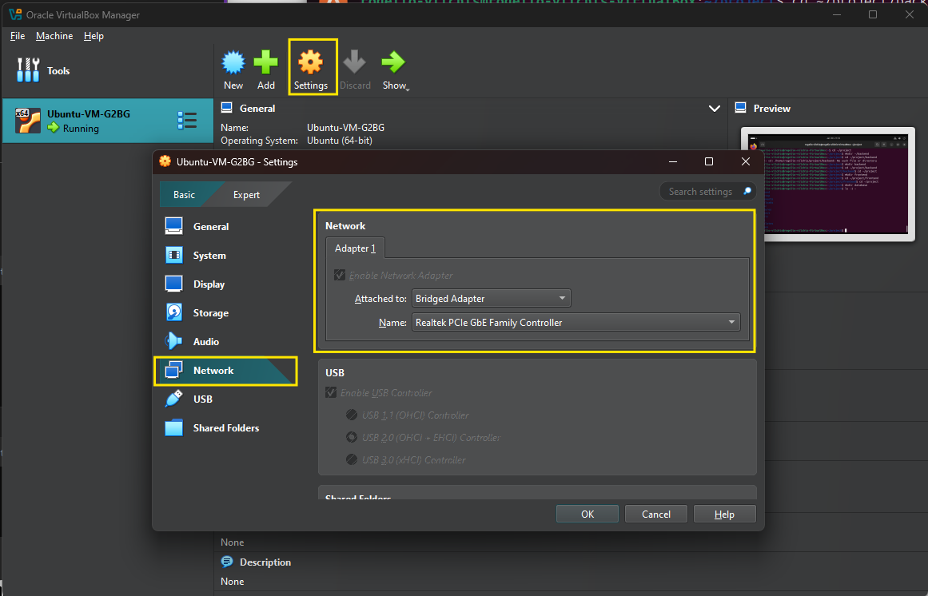
  - Restart your VM to apply changes.

- Open the Terminal
  - CTRL + ALT + T

- Type “cd ~/project/backend” hit Enter

- Type the following commands individually then hit enter after each one.

  - “npm init -y”
  - “npm install express”
  - “nano server.js” – A window will pop up
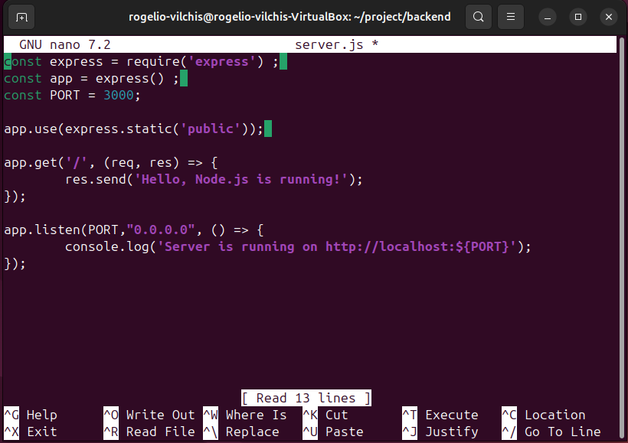
- Enter the above text
- Hit CTRL + o > Enter > CTRL + x

- Restart server
  - Type “node server.js” hit Enter
  - You should receive an output like “Server is running on ….”
  - If not restart your VM and try again

- In your terminal type “ip addr show” and hit enter
  - The IP address should be around this location
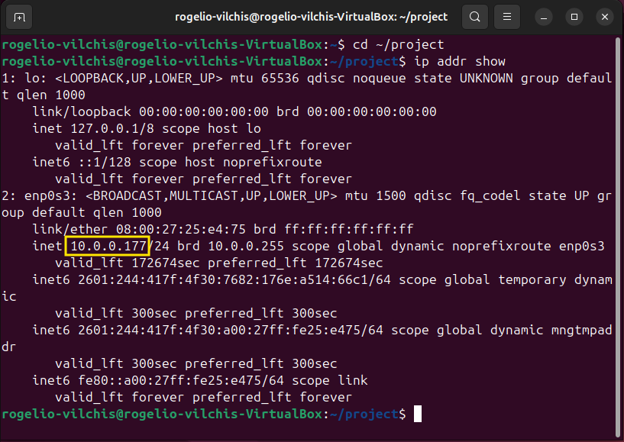

- Open up your browser and enter http://IPADDRESS:3000
  - You should see a webpage with the message we type earlier.

FINAL PART
- Connecting MySQL with phpMyAdmin

- Open your terminal
  - CTRL + ALT + T

- Go to MySQL
  - In ‘cd ~/project/backend’ type “sudo mysql -u root”

- We have to set a password – Enter the following commands and replace password with your password. Please keep note of the password we need it to log into phpMyAdmin.
  - Type “ALTER USER 'root'@'localhost' IDENTIFIED WITH mysql_native_password BY 'YourNewPassword';” then hit ENTER
  - Type “FLUSH PRIVILEGES;” then hit ENTER
  - Type “EXIT;” then hit ENTER
  - Type “sudo service mysql restart” then hit ENTER

- No syntax errors should appear. If you want to verify your password saved enter the following:
  - Type “sudo mysql -u root” then hit enter
  - Type “SELECT user, host, authentication_string, plugin FROM mysql.user WHERE user = 'root';” Then hit ENTER
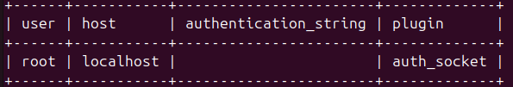
  - Your password should appear under authentication_string
  - To exit - Type “EXIT;” then hit ENTER

- Now we are going to set up the phpMyAdmin
- We check to see if its installed correctly
  - Type “ls /usr/share/phpMyAdmin” hit ENTER
  - If you see a list of files then it’s installed correctly.

- Type and hit enter for the following
  - ”sudo apt update”
  - “sudo apt install phpMyAdmin -y”
- Now we’re creating alink to the directory
  - Type “ls /usr/share/phpMyAdmin” hit ENTER
  - Type “apachectl -S 2>/dev/null | grep "Main Document Root"” then hit ENTER
  - Type “sudo ln -s /usr/share/phpmyadmin /var/www/html/phpMyAdmin” then hit ENTER
  - Type “sudo service apache2 restart” then hit enter

- Now on your VM open firefox and in the URL type
  - http://localhost/phpmyadmin
  - Username = root
  - Password is the password you set up when you were in MySQL.

